# **Community on Windows**

## A beginner's guide to customizing the installation

## **Table of Contents**

· [Introduction](https://medium.com/informatics/how-to-install-visual-studio-2022-community-on-windows-8d14365c2fd9#cd7d)· [Install VS Installer and Core Editor](https://medium.com/informatics/how-to-install-visual-studio-2022-community-on-windows-8d14365c2fd9#3e87)· [Install Components of Tools and Features](https://medium.com/informatics/how-to-install-visual-studio-2022-community-on-windows-8d14365c2fd9#37fa)· [Install/Uninstall Components](https://medium.com/informatics/how-to-install-visual-studio-2022-community-on-windows-8d14365c2fd9#ef6d)· [Summary](https://medium.com/informatics/how-to-install-visual-studio-2022-community-on-windows-8d14365c2fd9#9d62)· [References](https://medium.com/informatics/how-to-install-visual-studio-2022-community-on-windows-8d14365c2fd9#416b)

# **Introduction**

Visual Studio — often abbreviated as VS — is an IDE used to edit, compile, test, and run program code. Visual Studio 2022 is the first 64-bit of VS. Microsoft released version 17.0 on November 8, 2021. Three months later, Microsoft released version 17.1 on February 15, 2022, and version 17.1.1 on February 23, 2022.

There are three editions of Visual Studio:

1. VS Community. It is a free edition, fully-featured IDE for students, open-source and individual developers.
2. VS Professional. It's developer tools, services, and subscription benefits for small teams.
3. VS Enterprise. It's an end-to-end solution to meet the demanding quality and scale needs of teams of all sizes. Enterprise organizations are defined as >250 PCs or > $1 Million US Dollars in annual revenue.

The comparison of the three editions is as follows.

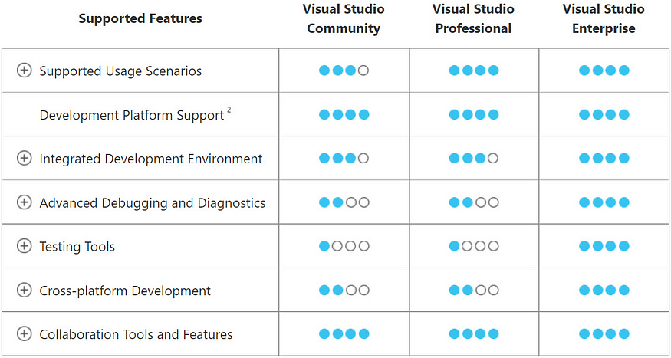

Figure 1 Visual Studio edition comparison (Microsoft, 2022)

This article discusses the stages of installing Visual Studio Community 2022. The following are the steps:  
• install *VS Installer* and *core editor*• install components of tools and features  
• install/uninstall components.

Before installing, you should check the [system requirements](https://docs.microsoft.com/en-us/visualstudio/releases/2022/system-requirements) to know whether your computer supports Visual Studio 2022.

# **Install VS Installer and Core Editor**

* Download Visual Studio 2022 [here](https://visualstudio.microsoft.com/downloads/). (https://visualstudio.microsoft.com/downloads/)

